[Brendan`s Forge] Site Plan

[Brendan Lockwood]

WDD 130

Overview

Purpose
[Make a portal page for all of my creations in wdd130]

Audience
[Anyone who wants to see what I made]

Branding

Website Logo



Style Guide

Color Palette
Primary | Secondary | Accent 1 | Accent 2
86CB92 | 71B48D | 000000 | 251F47

Typography

Heading Font: [Cloister Black]

Paragraph Font: [Roboto]

Navigation with Hover
HomePage2Contact Us

Site Map
Home
[Page2]
Contact Us

Wireframes

Home
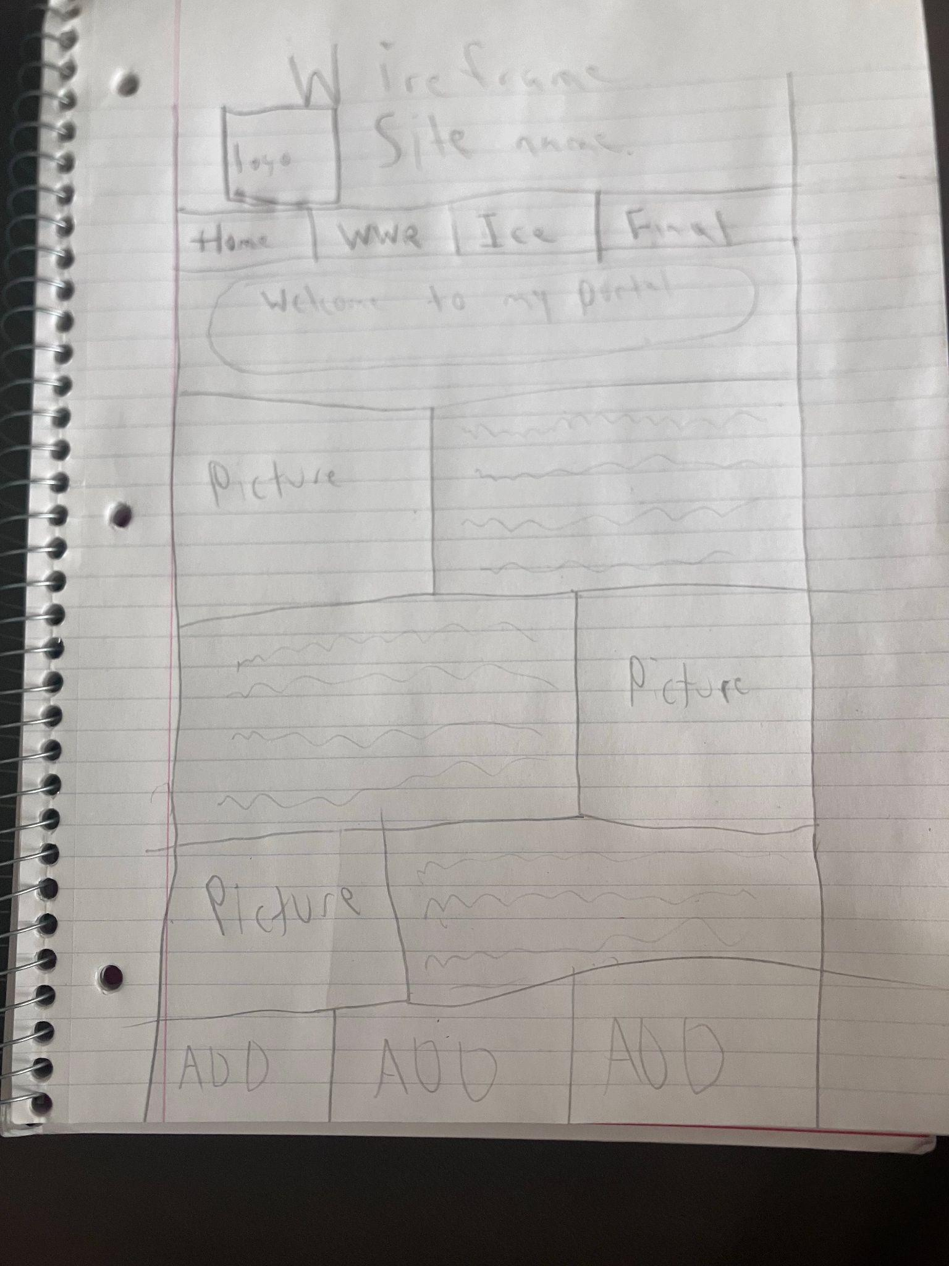

[Page 2]

